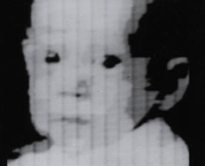1957- The first digital image is produced on a computer by Russell Kirsch for the United States National Bureau of Standards created a rotating drum that allowed images to be scanned. Using this device, he scanned a 5 centimeter by 5 centimeter shot of his son into the computer.

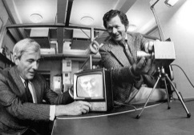

1969- At Bell Labs, George Smith and Willard Boyle invent the Charged Couple Device (CCD), the image sensor that is one of the main components of the digital camera. A year later, the CCD was built into the world’s first solid state camera.

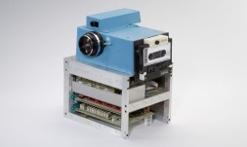

1975- Steve Sasson, an engineer at Kodak, invents the first ever digital camera was a fairly rudimentary affair compared to what we use today.

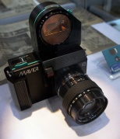

1981- The first prototype digital camera is produced by Sony called the Mavica. Is records images as magnetic impulses on a compact 2inch floppy disc.

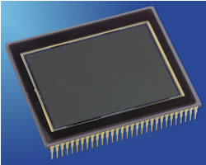

1986- Kodak scientists invent the first megapixel sensor, capable of recording 1.4 million pixels.

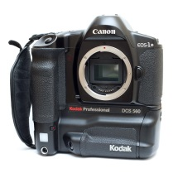

1991- Kodak releases the first professional digital camera system (DCS), aimed at photojournalists. It was a Nikon F-3 camera equipped by Kodak with a 1.3 megapixel sensor.

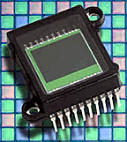

1990- Logitech comes out with the Dycam Model 1 black-and-white digicam, the world's first completely digital consumer camera. It stored 32 compressed images internally using 1MB RAM on a 376 x 240 pixel CCD at 256 shades of gray in TIFF format.

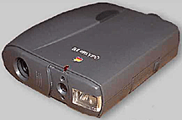1994- The Apple QuickTake 100 camera, the first digital cameras for the consumer-level market that workes with a home computer via a serial cable. This camera featured a 640 x 480 pixel CCD which produced eight images stored in internal memory. It also had a built-in flash.

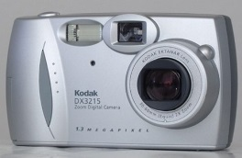

2001 Kodak puts out their Easy Share digital camera, making it easy to snap pictures and download them to the computer.

2002- Foveon produces a new image sensor. In this image sensor, individual photosites' (these are the pixels of the sensor) collect information about *either* red *or* green *or* blue light.

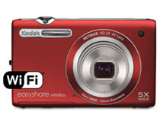

2012- Kodak puts out digital cameras that didn't have to be connected to a computer in order to download and share the pictures by using wifi using easy share.